**Special Problem 03**

Excellent job Carlos and your analysis are sound.

As I may have mentioned in Paper 2, be sure and investigate other Formal Analytic Models such as SMART, AHP, Even Swaps, etc. Also, checkout the Bayesian AoA tool called Accord from Robust Decisions.

20/20

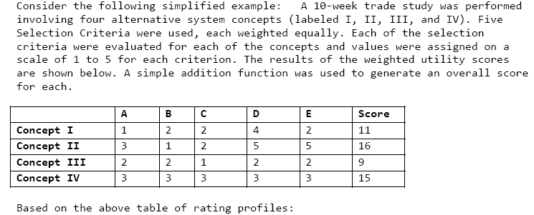

**Question 1**:



**Response**:

In my honest opinion, with the information provided in this simplified example, all options presented are would potentially be equally superior at this moment in time. Several key factors are missing in order to allow me as a Systems Engineer to go ahead and make the decision for the superior concept.

The trade study itself needs an objective, which is guiding the need for this analysis to be performed in the first place. Even though there are 4 candidate concepts, it is difficult to determine which one to pick because the Customer’s needs and “hot buttons” for this program are completely unknown. For example, if the driving factor for the trade study (from the Customer’s perspective) was cost, then that specific factor would need to be weighed heaviest of all selection criteria. However, with all equal weights, the trade study fails to identify the importance of that factor. This example also exposes the ambiguity in having a trade study contain equal weighting for unknown factors.

Granted, at first glance, one would probably be most inclined select either Concepts II or IV, since their overall utility scores are the highest (with the assumption that a 5 >> 1 in scoring). If the Customer cared more about criteria D/E the most, then the clear choice is Concept II. However, if the interest was more inclined towards adequate uniformity across the criteria, then Concept IV is the clear choice.

With the assumptions of equal weighting in selection categories and that a 5 is greater than a 1 in scoring, my selection would be either Concept II or Concept IV. This is selection is made at risk, fully undestanding the uncertainties identified in the paragraphs above.

**Question 2**:

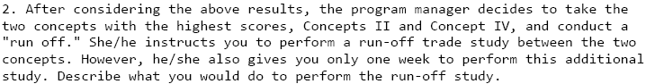

**Response**:

Now with clear direction for my program manager to conduct a “run off” between the two concepts with the highest scores, Concept II and Concept IV, my feelings of discomfort and uncertainty are greatly lessened. A few points of information to reiterate from these two selections:

* II and IV have scored the highest on a criteria sheet, so I know that they are at least satisfying the core requirements of the concept which have been defined.
* Concept II has scored significantly higher than Concept IV in selection criteria D & E, so I would start my research by reexamining both of Concepts against D and E in greater detail.
* Concept II has scored significantly lower than Concept IV in selection criteria B, so that is another area which needs to be further explored.

Given a total of 5 working days to perform the run-off study, the following is a proposed plan of attack:

***Monday*** –

Research all factors and information regarding D. Also, reexamine scoring to determine if correct decision for point value was made or if there was inflation in the subjectivity.

***Tuesday*** –

Research all factors and information regarding E. Also, reexamine scoring to determine if correct decision for point value was made or if there was inflation in the subjectivity.

***Wednesday*** –

Research all factors and information regarding B. Also, reexamine scoring to determine if correct decision for point value was made or if there was inflation in the subjectivity.

***Thursday*** –

Analyze all data compiled in order to formulate an opinion and determination for which concept is the best. Talk to design engineers regarding the following conversation: “If we chose Concept II/IV, what are your impacts?”. Also, discuss management risks (cost/schedule) and risk mitigation plans for both concepts.

***Friday*** –

Compile thoughts and overall conclusion. Prepare for presentation on Monday with program manager.

With only knowing that amount of data contained in the table, the plan I propose above would describe my thought process in how I would go about choosing between Concepts II and IV. For Systems Engineers, it is extremely important to realize that the best decision doesn’t always align with the Concept that scored highest in a trade study. In order to properly conduct a trade study, one must know which factors mean more than others and how much risk one is willing to take with the decisions that are made. I wouldn’t blindly select Concept II simply because it scored higher than Concept IV – I would need to perform further detailed analysis and truly understanding the trade space before proposing, and ultimately, making the final decision.